# IT 315 Final Project Part II Solution Submission Template

This template is a guide for you to organize your information. To complete it, **replace the bracketed text with the relevant information.** Some areas may be too large or too small for the information you’re inserting. Adjust the size of the areas as necessary.

**Name:** [Joseph Silva Jr.]

**Date:** [01/31/21]

1. Using this class responsibility collaboration (CRC) card template, document each class you identified from your student information system (SIS) functional model.

**CRC Card 1:**

|  |  |  |  |
| --- | --- | --- | --- |
| Front: | | | |
| Class Name:  [Manage Class Records] | ID:  [1] | | Type:  [Concrete, Detail] |
| Description:  [A system that stores and allows access to class records] | | | Associated Use Cases:  [7] |
| Responsibilities:   * Store Records * Give Records’ edit access to Staff member. * Displays Records for Staff and Student. | | Collaborators:   * Class | |
| Back: | | | |
| Attributes:   * Course ID (text) * Begin Date (text) * End Date (text) * Type of Class (text) | | | |
| Relationships   * Generalization (a-kind-of):   [Class.]   * Aggregation (has-parts):   [Couse.]   * Other Associations:   [Staff, Student, Online Class, F2F Class, & Student Registration] | | | |

**CRC Card 2:**

|  |  |  |  |
| --- | --- | --- | --- |
| Front: | | | |
| Class Name:  [Manage Course Records] | ID:  [2] | | Type:  [Concrete, Detail] |
| Description:  [A system that stores and allows access to course records] | | | Associated Use Cases:  [4] |
| Responsibilities:   * Store Records * Give Records’ edit access to Staff member. * Display for Staff and Student. | | Collaborators:   * Course | |
| Back: | | | |
| Attributes:   * Course ID (text) * Course Name (text) * Credit Hours (text) * Description (text) * Prerequisite Course (text) | | | |
| Relationships   * Generalization (a-kind-of):   [Course.]   * Aggregation (has-parts):   []   * Other Associations:   [Staff, Student, & Manage Class Records] | | | |

**CRC Card 3:**

|  |  |  |  |
| --- | --- | --- | --- |
| Front: | | | |
| Class Name:  [Manage Students’ Records] | ID:  [3] | | Type:  [Concrete, Detail] |
| Description:  [A system that stores and allows access to Student records.] | | | Associated Use Cases:  [4] |
| Responsibilities:   * Store Records * Give Records’ edit access to Staff member. * Display for Staff and Student. | | Collaborators:   * Student Record | |
| Back: | | | |
| Attributes:   * Student’s First Name, Middle Initial, & Last Name (text) * Student’s DOB (text) * Student ID (text) * Department (text) * Cumulative GPA (scale: 0.0 – 4.0) (text) | | | |
| Relationships   * Generalization (a-kind-of):   [Student Records]   * Aggregation (has-parts): * Other Associations:   [Staff, Student, & Student Registration] | | | |

**CRC Card 4:**

|  |  |  |  |
| --- | --- | --- | --- |
| Front: | | | |
| Class Name:  [Student Registration] | ID:  [4] | | Type:  [Concrete, Detail] |
| Description:  [A Staff Member that can access and edit records.] | | | Associated Use Cases:  [5] |
| Responsibilities:   * Request a Student ID * Confirms Student ID with Student Records * Retrieves Cumulative GPA from Student Records of the associated Student ID. * Gives access to modify the Class Registration query of the associated Student ID. * Displays classes from Class Records to allow registration. * Does not allow duplicate classes in Student ID’s registration query. * Prevents a 4th class registration if associated Student ID’s cumulative GPA is lower than 3.5 | | Collaborators:   * Student Registration | |
| Back: | | | |
| Attributes:   * Name (text) * Employee ID (text) * Email (text) * Phone Number (text) * Department (text) | | | |
| Relationships   * Generalization (a-kind-of):   [Student Registration]   * Aggregation (has-parts):   [Manage Class Records & Student Records]   * Other Associations:   [Staff & Student] | | | |

**CRC Card 5:**

|  |  |  |  |
| --- | --- | --- | --- |
| Front: | | | |
| Class Name:  [Online Classes Records] | ID:  [5] | | Type:  [Concrete, Detail] |
| Description:  [A Staff Member that can access and edit records.] | | | Associated Use Cases:  [3] |
| Responsibilities:   * Displays and links Web Browser. * Displays Web URL | | Collaborators:   * Online Class | |
| Back: | | | |
| Attributes:   * Web URL (text) * Web Browser (link) | | | |
| Relationships   * Generalization (a-kind-of):   [Class]   * Aggregation (has-parts): * Other Associations:   [Staff & Student] | | | |

**CRC Card 6:**

|  |  |  |  |
| --- | --- | --- | --- |
| Front: | | | |
| Class Name:  [F2F Class Records] | ID:  [6] | | Type:  [Concrete, Detail] |
| Description:  [A Staff Member that can access and edit records.] | | | Associated Use Cases:  [3] |
| Responsibilities:   * Display Classroom Information * Display Building Information | | Collaborators:   * F2F Class | |
| Back: | | | |
| Attributes:   * Building Number / Letter / Name (text) * Classroom Number / Letter / Name (text) | | | |
| Relationships   * Generalization (a-kind-of):   [Class]   * Aggregation (has-parts): * Other Associations:   [Student & Staff] | | | |

**CRC Card 7:**

|  |  |  |  |
| --- | --- | --- | --- |
| Front: | | | |
| Class Name:  [Staff] | ID:  [7] | | Type:  [Concrete, Detail] |
| Description:  [A Staff Member that can access and edit records.] | | | Associated Use Cases:  [6] |
| Responsibilities:   * Able to Review Course Records. * Able to Edit Course Records. * Able to Add Course Records. * Able to Delete Course Records. * Able to Review Class Records. * Able to Edit Class Records. * Able to Add Class Records. * Able to Delete Class Records. * Able to Review Online Class Records. * Able to Review F2F Class Records. * Able to Review Student Records. * Able to Edit Student Records. * Able to Add Student Records. * Able to Delete Student Records. * Able to access and modify an associated Student’s ID classes within the Student Registration . | | Collaborators:   * Course * Class * Online Class * F2F Class * Student Records * Student Registration | |
| Back: | | | |
| Attributes:   * Name (text) * Employee ID (text) * Email (text) * Phone Number (text) * Department (text) | | | |
| Relationships   * Generalization (a-kind-of):   [Person]   * Aggregation (has-parts): * Other Associations:   [Class, Course, Student Records, Online Class, F2F Class, & Student Registration] | | | |

**CRC Card 8:**

|  |  |  |  |
| --- | --- | --- | --- |
| Front: | | | |
| Class Name:  [Student] | ID:  [8] | | Type:  [Concrete, Detail] |
| Description:  [A Student that can access records and modify in the Student Registration process.] | | | Associated Use Cases:  [6] |
| Responsibilities:   * Able to Review Course Records. * Able to Review Class Records. * Able to Review Online Class Records. * Able to Review F2F Class Records. * Able to Review Student Records. * Able to access and modify an associated Student’s ID classes within the Student Registration . | | Collaborators:   * Course * Class * Online Class * F2F Class * Student Records * Student Registration | |
| Back: | | | |
| Attributes:   * Name (text) * DOB (text) * Student ID (text) * Email (text) * Phone Number (text) | | | |
| Relationships   * Generalization (a-kind-of):   [Person]   * Aggregation (has-parts): * Other Associations:   [Class, Course, Student Records, Online Class, F2F Class, & Student Registration] | | | |

Generate your SIS class diagram:

[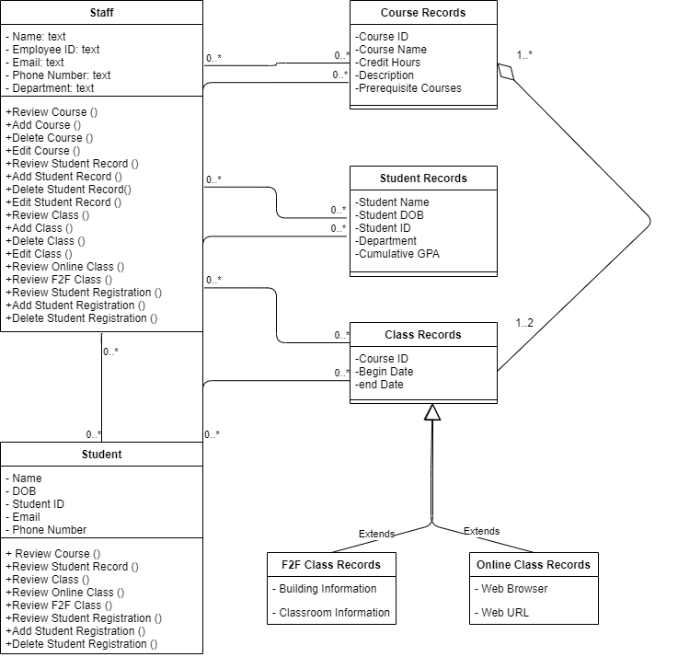]

1. Verify and validate your CRC cards and class diagram against your SIS functional model:

[The CRC cards has the front of the card displaying information such as: the Class Name, ID, Type, Description, Associated Cases, Responsibilities, and Collaborators. They have the back of the cards displaying information such as: Attributes and Relationships.

I compared the CRC cards to the SIS system guideline, and I believe they match each other. The records systems and their CRC cards show the names and descriptions for these use cases. The CRC cards are very easy to use when they are created correctly because they are like flash cards, which given information about the particular part of the system. I was able to show the different types of relationships between use cases and actors. The CRC cards make the information required for each use case within the system organized and available. I also was able to create CRC cards to make information about each actor also organized and available. For the actors CRC cards, the Staff responsibilities were able to gain access to use case records in order to review and edit them. The Students responsibilities were able to gain access to use cases in order to review them, but only able to edit the student’s registration. The attributes of the staff and students were personally created in order to show the staff member’s identity in order for the system to later identify when the records were accessed and possibly edited. ]

1. Explain your approach to the problem, the decisions you made to arrive at your solution, and how you completed it:

[I used last week’s discussion, Final Milestone 1, SIS Guideline & the schoolbook as resources in creating my CRC cards and diagram. When it came to creating the CRC cards, I used last week’s discussion as an example in order to build the additional cards needed for this assignment and the creation of the model, I used the book as a resource in order to follow the definitions for the relationships and creation of each use case. The model was something I had a difficult time creating because of the different types of models shown in the book. I was trying to mimic the best one that would represent the information in this assignment.]

1. Reflect on this experience and the lessons you learned from it:

[I learned a lot about CRC cards and their creation last week, which helped me with this assignment. The discussion last week made it any easy transition to create and place information into the CRC cards. I learned about the different types of relationships within a class diagram and how to establish them to show the attributes and the operations that go into each use case. The lesson I learned about this class diagram was how to create them on drawio, which was very helpful.]